**Database Options: mLab vs MongoDB Atlas**

Since I recorded these lectures, there has been a change in [mLab](https://mlab.com/)

You will learn about mLab in the next lecture.

When you [visit https://mlab.com/](https://mlab.com/) for signup.

You will see the following alert on top of the page:

[**mLab is now part of MongoDB, Inc.**](https://docs.mlab.com/mlab-to-atlas/)

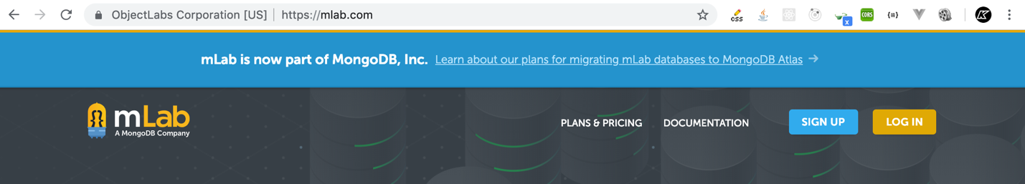

mLab is now closed to new signups. So If you are not existing user at mLab, you need to create a new account in MongoDB Atlas.

You can use MongoDB Atlas which is similar to mLab.

**How to get started with MongoDB Atlas?**

I have written a step by step article that will help you get started with MongoDB Atlas. Please **skip the signup parts only in next lecture** (*Signup with mlab to use mongodb*)  and instead go to the Lecture (article) that comes after the next lecture (Signup with MongoDB Atlas to use mongodb)

Except signup process, everything else will be similar wheather you are using mLab or MongoDB Atlas.